***Assignment – 13 || Structure***

*Arjun Patel – FRN13J1124/006*

Q1)Student

#include<stdio.h>

#include<string.h>

struct Student{

    int rollNo;

    char name[30];

    int marks5[2]; ///marks of two subjects

};

int main(){

    struct Student s1, s2, s3;

    s1.rollNo = 1;

    printf("Enter name\n");

    scanf("%s", s1.name);

    for (int i = 0; i < 2; i++)

    {

        printf("Enter marks for %d\n", i+1);

        scanf("%d", &s1.marks5[i]);

    }

    s2.rollNo = 2;

    strcpy(s2.name, "Mike");

    s2.marks5[0] = 60;

    s2.marks5[1] = 90;

    s3.rollNo = 3;

    strcpy(s3.name, "Messi");

    s3.marks5[0] = 70;

    s3.marks5[1] = 95;

    printf("\nRollNo-> %d  Name-> %s  Marks1->%d  Marks2->%d\n", s1.rollNo, s1.name, s1.marks5[0], s1.marks5[1]);

    printf("\nRollNo-> %d  Name-> %s  Marks1->%d  Marks2->%d\n", s2.rollNo, s2.name, s2.marks5[0], s2.marks5[1]);

    printf("\nRollNo-> %d  Name-> %s  Marks1->%d  Marks2->%d\n", s3.rollNo, s3.name, s3.marks5[0], s3.marks5[1]);

    return 0;

}

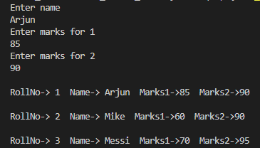

Q2)Employee

#include<stdio.h>

#include<string.h>

struct Employee{

    int id;

    char name[30];

    int salary;

};

int main(){

    struct Employee e1, e2;

    e1.id = 1;

    strcpy(e1.name, "Messi");

    printf("Enter name\n");

    scanf("%s", e1.name);

    printf("Enter salary\n");

    scanf("%d", &e1.salary);

    e2.id = 2;

    strcpy(e2.name, "Ronaldo");

    e2.salary = 900000;

    printf("\nid-> %d  Name-> %s  Salary->%d\n", e1.id, e1.name, e1.salary);

    printf("\nid-> %d  Name-> %s  Salary->%d\n", e2.id, e2.name, e2.salary);

    return 0;

}

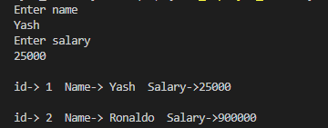

Q3) Admin

#include<stdio.h>

#include<string.h>

struct Admin{

    int id;

    char name[30];

    int salary;

    int allowance;

};

int main(){

    struct Admin a1, a2;

    a1.id = 1;

    printf("Enter name\n");

    scanf("%s", a1.name);

    printf("Enter salary\n");

    scanf("%d", &a1.salary);

    printf("Enter allowance\n");

    scanf("%d", &a1.allowance);

    a2.id = 2;

    strcpy(a2.name, "Ravi");

    a2.salary = 16000;

    a2.allowance = 6500;

    printf("\nid-> %d  Name-> %s  Salary->%d  Allowance->%d\n", a1.id, a1.name, a1.salary, a1.allowance);

    printf("\nid-> %d  Name-> %s  Salary->%d  Allowance->%d\n", a2.id, a2.name, a2.salary, a2.allowance);

    return 0;

}

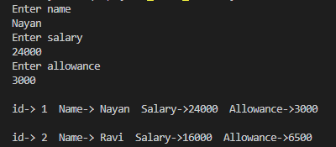

Q4) HR

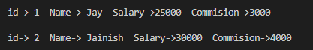

#include<stdio.h>

#include<string.h>

struct HR{

    int id;

    char name[30];

    int salary;

    int commision;

};

int main(){

    struct HR h1, h2;

    h1.id = 1;

    printf("Enter name\n");

    scanf("%s", h1.name);

    printf("Enter salary\n");

    scanf("%d", &h1.salary);

    printf("Enter Commision\n");

    scanf("%d", &h1.commision);

    h2.id = 2;

    strcpy(h2.name, "Jainish");

    h2.salary = 30000;

    h2.commision = 4000;

    printf("\nid-> %d  Name-> %s  Salary->%d  Commision->%d\n", h1.id, h1.name, h1.salary, h1.commision);

    printf("\nid-> %d  Name-> %s  Salary->%d  Commision->%d\n\n", h2.id, h2.name, h2.salary, h2.commision);

    return 0;

}

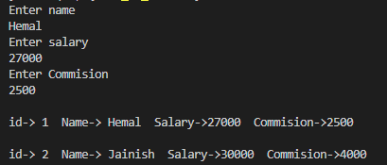

Q5) SalesManager

#include<stdio.h>

#include<string.h>

struct SalesManager{

    int id;

    char name[30];

    int salary;

    int incentive;

    int target;

};

int main(){

    struct SalesManager s1, s2;

    s1.id = 1;

    printf("Enter Name for s1\n");

    scanf("%s", s1.name);

    printf("Enter Salary for s1\n");

    scanf("%d", &s1.salary);

    printf("Enter incentive for s1\n");

    scanf("%d", &s1.incentive);

    printf("Enter incentive for s1\n");

    scanf("%d", &s1.target);

    s2.id = 2;

    strcpy(s2.name, "Jainish");

    s2.salary = 30000;

    s2.incentive = 4000;

    s2.target = 250;

    printf("\nid-> %d  Name-> %s  Salary->%d  Incentive->%d\n Target->%d\n", s1.id, s1.name, s1.salary, s1.incentive, s1.target);

    printf("\nid-> %d  Name-> %s  Salary->%d  Incentive->%d\n Target->%d\n\n", s2.id, s2.name, s2.salary, s2.incentive, s2.target);

    return 0;

}

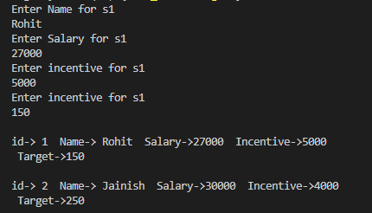

Q6) Date

#include<stdio.h>

#include<string.h>

struct Date{

    int date;

    int month;

    int year;

};

int main(){

    struct Date d1,d2;

    printf("Enter Date\n");

    scanf("%d", &d1.date);

    printf("Enter Month\n");

    scanf("%d", &d1.month);

    printf("Enter Year\n");

    scanf("%d", &d1.year);

    d2.date = 2;

    d2.month = 12;

    d2.year = 2024;

    printf("\nDate-> %d  Month-> %d  Year->%d\n", d1.date, d1.month, d1.year);

    printf("\nDate-> %d  Month-> %d  Year->%d\n", d2.date, d2.month, d2.year);

    return 0;

}

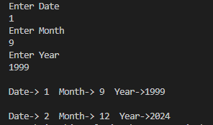

Q7) Time

#include<stdio.h>

#include<string.h>

struct Time{

    int hr;

    int min;

    int sec;

};

int main(){

    struct Time t1,t2;

    printf("Enter Hour\n");

    scanf("%d", &t1.hr);

    printf("Enter Minutes\n");

    scanf("%d", &t1.min);

    printf("Enter Seconds\n");

    scanf("%d", &t1.sec);

    t2.hr = 2;

    t2.min = 20;

    t2.sec = 23;

    printf("\nHr-> %d  Minutes-> %d  Seconds->%d\n", t1.hr, t1.min, t1.sec);

    printf("\Hour-> %d  Minutes-> %d  Seconds->%d\n", t2.hr, t2.min, t2.sec);

    return 0;

}

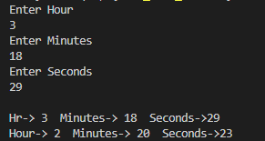

Q8) Distance

#include<stdio.h>

#include<string.h>

struct Distance{

    float feet;

    float inch;

};

int main(){

    struct Distance t1,t2;

    printf("Enter Feet\n");

    scanf("%f", &t1.feet);

    printf("Enter Inch\n");

    scanf("%f", &t1.inch);

    t2.feet = 2;

    t2.inch = 20;

    printf("\n%.2f feets, %.2f  inchs", t1.feet, t1.inch);

    printf("\n%.2f feets, %.2f  inchs", t1.feet, t2.inch);

    return 0;

}

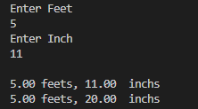

Q9) Complex

#include<stdio.h>

#include<string.h>

struct Complex{

    int real;

    int img;

};

int main(){

    struct Complex c1,c2;

    printf("Enter Real Part\n");

    scanf("%d", &c1.real);

    printf("Enter Imaginary\n");

    scanf("%d", &c1.img);

    c2.real = 2;

    c2.img = 20;

    printf("\n%d + %di\n", c1.real, c1.img);

    printf("\n%d + %di\n\n", c2.real, c2.img);

    return 0;

}

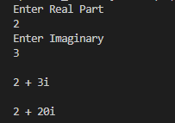

Q10) Product

#include<stdio.h>

#include<string.h>

struct Product{

    int id;

    char name[30];

    int quantity;

    int price;

};

int main(){

    struct Product p1, p2;

    p1.id = 1;

    printf("Enter Name of product1\n");

    scanf("%s", p1.name);

    printf("Enter quantity for product1\n");

    scanf("%d", &p1.quantity);

    printf("Enter price for product1\n");

    scanf("%d", &p1.price);

    p2.id = 2;

    strcpy(p2.name, "Milk");

    p2.quantity = 5;

    p2.price = 40;

    printf("\nid-> %d  Name-> %s  quantity->%d  price->%d totalAmount->%d rs.\n", p1.id, p1.name, p1.quantity, p1.price, p1.quantity * p1.price);

    printf("\nid-> %d  Name-> %s  quantity->%d  price->%d totalAmount->%d rs.\n", p2.id, p2.name, p2.quantity, p2.price, p2.quantity * p2.price);

    return 0;

}

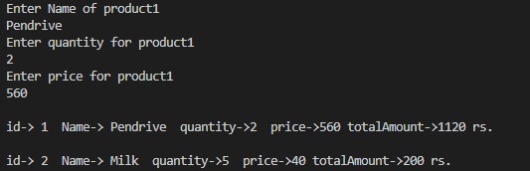

***------END------***